# ANDERSON VALLEY HEALTH CENTER, INC.

### EXECUTIVE SUMMARY MAY 2025

|  |  |  |  |
| --- | --- | --- | --- |
|  | **STATEMENT OF FINANCIAL POSITION** |  |  |
| **ASSETS** | **May‐25 May‐24 Change** | **Apr‐25** | **Change** |
| Current Assets | 3,977,357 3,042,245 30.74% | 3,971,938 | 0.14% |
| Long Term Assets | 6,379,941 7,076,671 ‐9.85% | 6,408,175 | ‐0.44% |
| **TOTAL ASSETS** | 10,357,298 10,118,915 2.36% | 10,380,113 | ‐0.22% |
| **LIABILITIES AND NET ASSETS** |  |  |  |
| Current Liabilities | 762,408 776,968 ‐1.87% | 785,996 | ‐3.00% |
| Estimated Medi‐Cal Liabilities | 263,453 154,762 70.23% | 278,540 | ‐5.42% |
| Long‐Term Debt | 466,735 557,419 ‐16.27% | 474,374 | ‐1.61% |
| Total Liabilities | 1,492,597 1,489,149 0.23% | 1,538,910 | ‐3.01% |
| Net Assets | 8,864,701 8,629,766 2.72% | 8,841,203 | 0.27% |
| **TOTAL LIABILITIES AND NET ASSETS** | 10,357,298 10,118,915 2.36% | 10,380,113 | ‐0.22% |
|  | **STATEMENT OF ACTIVITIES ‐ YTD** |  |  |
| **REVENUES** | **Actual Budget Variance** | **Prior Year** | **Variance** |
| Patient Service Revenue | 3,093,917 3,099,544 ‐0.18% | 2,998,251 | 3.19% |
| Grant & Other Revenue | 2,852,752 2,475,319 15.25% | 2,625,749 | 8.65% |
| **NET REVENUE** | 5,946,669 5,574,863 6.67% | 5,624,000 | 5.74% |
| **OPERATING EXPENSES** |  |  |  |
| Salaries and Benefits | 3,616,113 3,957,066 ‐8.62% | 3,653,161 | ‐1.01% |
| Contracted Services | 292,009 27,080 978.32% | 249,094 | 17.23% |
| Facility Costs | 153,258 146,832 4.38% | 181,867 | ‐15.73% |
| Supplies | 251,529 202,818 24.02% | 232,024 | 8.41% |
| Depreciation & Amortization | 272,929 293,851 ‐7.12% | 250,655 | 8.89% |
| Other Operating Expenses | 1,133,933 972,278 16.63% | 1,122,751 | 1.00% |
| **TOTAL OPERATING EXPENSES** | 5,719,772 5,599,925 2.14% | 5,689,552 | 0.53% |
| **OPERATING EXCESS/(DEFICIENCY)** | 226,897 (25,062) 1005.34% | (65,552) | ‐446.13% |
| Net Capital Income/(Expenses) | 92,935 24,398 280.91% | 105,493 | ‐11.90% |
| **TOTAL EXCESS/(DEFICIENCY)** | 319,832 (664) | 39,942 | 700.75% |

Page 1 of 5

|  |  |  |  |  |  |  |  |  |  |  |  |  |  |
| --- | --- | --- | --- | --- | --- | --- | --- | --- | --- | --- | --- | --- | --- |
| **STATEMENT OF ACTIVITIES BY DEPARTMENT‐ CURRENT MONTH** | | | | | | | | | | | | | |
|  |  |  |  |  | **Behavioral** |  |  |  |  |  |  |  |  |
| **REVENUES** | **Medical** |  | **Acupuncture** |  | **Health** |  | **Dental** |  | **Dispensary** |  | **Admin** |  | **Total** |
| Patient Service Revenue | 106,951 |  | 23,529 |  | 37,403 |  | 149,932 |  | 10,514 |  | ‐ |  | 328,330 |
| Grant & Other Revenue | 115,161 |  | 20,588 |  | 55,163 |  | 41,219 |  | 10,437 |  | 19,352 |  | 261,921 |
| **NET REVENUE** | 222,113 |  | 44,117 |  | 92,566 |  | 191,152 |  | 20,951 |  | 19,352 |  | 590,252 |
| **OPERATING EXPENSES** |  |  |  |  |  |  |  |  |  |  |  |  |  |
| Salaries and Benefits | 122,913 |  | 9,995 |  | 26,521 |  | 34,303 |  | 12,876 |  | 138,550 |  | 345,157 |
| Contracted Services | 1,200 |  | ‐ |  | (216) |  | 58,719 |  | ‐ |  | 984 |  | 60,687 |
| Facility Costs | 3,782 |  | 392 |  | 858 |  | 1,221 |  | 72 |  | 6,669 |  | 12,994 |
| Supplies | 5,465 |  | 2,459 |  | ‐ |  | 5,790 |  | 3,714 |  | 1,657 |  | 19,087 |
| Depreciation & Amortization | 4,732 |  | 2,280 |  | 1,368 |  | 2,031 |  | 526 |  | 17,297 |  | 28,234 |
| Other Operating Expenses | 12,574 |  | 637 |  | 6,831 |  | 4,198 |  | 660 |  | 90,805 |  | 115,705 |
| **TOTAL DIRECT EXPENSES** | 150,666 |  | 15,763 |  | 35,362 |  | 106,263 |  | 17,849 |  | 255,961 |  | 581,864 |
| Administrative Costs | 125,290 |  | 12,090 |  | 23,354 |  | 61,509 |  | 14,366 |  | (236,609) |  | ‐ |
| **TOTAL OPERATING EXPENSES** | 275,956 |  | 27,853 |  | 58,716 |  | 167,772 |  | 32,215 |  | 19,352 |  | 581,864 |
| **OPERATING EXCESS/(DEFICIENCY)** | (53,843) |  | 16,264 |  | 33,850 |  | 23,380 |  | (11,264) |  | ‐ |  | 8,388 |
| Net Capital Income/(Expenses) | ‐ |  | ‐ |  | ‐ |  | ‐ |  | ‐ |  | 15,110 |  | 15,110 |
| **TOTAL EXCESS/(DEFICIENCY)** | (53,843) |  | 16,264 |  | 33,850 |  | 23,380 |  | (11,264) |  | 15,110 |  | 23,498 |

|  |  |
| --- | --- |
| **Cash on Hand**  $3.5M $2.9M $2.9M $3.0M $3.1M $3.2M $3.3M  $2.8M $2.9M $2.9M  $3.0M $2.5M  $2.5M $2.1M $2.0M $2.0M  $2.0M  $1.5M  $1.0M  $0.5M  $0.0M | **Current Ratio**  **Healthy = > 1.0, higher is better**  5.00    4.00  3.00  2.00  1.00  ‐ |
| **Days Unrestricted Cash on Hand Recommend > 60 days; higher is better**  250    200  150  100  50  ‐ | **Debt to Equity**  **Healthy = < 100%; lower is better**    19%  18%    17%  16%  15%  14% |
| **Days Net AR Outstanding Recommend < 45 days, lower is better**  120    100  80  60  40  20  ‐ | **Patient AR Balance**  $854K $826K  900,000.000 $773K $757K $712K $775K $786K $752K  800,000.000 $689K $693K  700,000.000 $602K  600,000.000  500,000.000  400,000.000  300,000.000  200,000.000  100,000.000  ‐  Jul‐24 Aug‐24 Sep‐24 Oct‐24 Nov‐24 Dec‐24 Jan‐25 Feb‐25 Mar‐25 Apr‐25 May‐25  0‐30  31‐60  61‐90  91‐120  120+ Total |

1,500

1,299

1,250 1,314

## Monthly Visits

1,314

1,231

1,385

1,378

1,337

1,477

1,314

1,250

1,000

750

500

250

‐

973

1,189

1,092

1,096

1,097

1,189

1,206

1,207

Dec‐24 Jan‐25 Feb‐25 Mar‐25 Apr‐25 May‐25

`

Current Period Prior Year Budget

800

700

600

500

400

563 590

## Monthly Visits by Department

629 597 579

523

319 279 267 344

475

300

158 148

157

148

146

142

168 190 169

200

100

‐

104 123

100 114

Dec‐24 Jan‐25 Feb‐25 Mar‐25 Apr‐25 May‐25

Medical Acupuncture Behavioral Health Dental

1,500

1,250

1,000

750

500

99

338

5

299

81

264

87

276

‐ 205

199

## Monthly Visits by Financial Class

70 12

18

10

71

240

272 267 255

1514

4

215

2

279

32

290

‐

242

62

308

77

4

241

264

21

‐ 1

99

260

1

259

250

251

283

1

106

275

68

272

2

‐

736 462 475 550 512 568 555 454 622 544 594 614 718

May‐24 Jun‐24 Jul‐24 Aug‐24 Sep‐24 Oct‐24 Nov‐24 Dec‐24 Jan‐25 Feb‐25 Mar‐25 Apr‐25 May‐25

Medi‐Cal Medicare Other Public Program Insurance Self‐Pay



## YTD PAYOR MIX

**5%**

OUTER LAYER = CURRENT YEAR MID LAYER = PRIOR YEAR

**9%** INNER LAYER = BUDGET

## Net Patient Revenue per Visit

350325.77

258.52 255.10 258.39 260.06 245.57

600

500

584.54

## Operating Cost per Visit

484.04

461.43

435.20

**24%**

**0%**

**24%**

**0%**

**10%**

**23%**

**1%**

**20%**

**20%**

**47%**

**47%**

**50%**

Medi‐Cal

Medicare

Other Public Program Insurance

250

150

50

400

300

200

100

0

454.26

416.76

80%

60%

40%

**20%**

34%

38%

Self‐Pay

62%

‐50

Dec‐24 Jan‐25 Feb‐25 Mar‐25 Apr‐25 May‐25

Current Year Actual Prior Year Actual Budget

## Payor Mix by Department

**YTD**

52%

Dec‐24 Jan‐25 Feb‐25 Mar‐25 Apr‐25 May‐25

Current Year Actual Prior Year Actual Budget

76%

25% 26%

5%

24%

19%

20%

0%

0% 3%

11%

0% 0% 0%

0% 0%

11%

13%

Medical Acupuncture Behavioral Health Dental

Medi‐Cal Medicare Other Public Program Insurance Self‐Pay

2,700

2,600

2,500

2,400

2,300

2,200

2,648 2,662 2,644

## Unduplicated Patients

SAC = 2,669

2,638 2,613 2,604 2,592

2,574

2,586 2,570

2,533 2,507

Jun‐24 Jul‐24 Aug‐24 Sep‐24 Oct‐24 Nov‐24 Dec‐24 Jan‐25 Feb‐25 Mar‐25 Apr‐25 May‐25

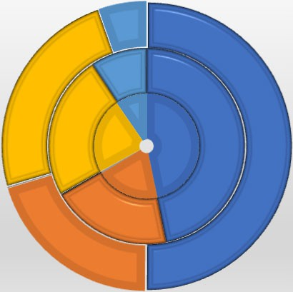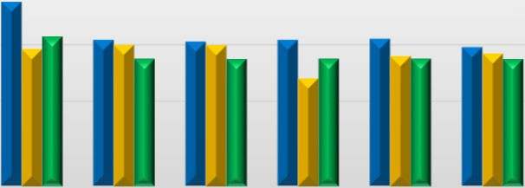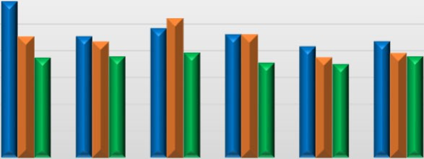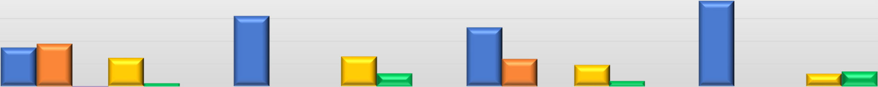

Current Year Prior Year